**CS561- ARTIFICIAL INTELLIGENCE LAB**

**ASSIGNMENT-6: Decision Trees**

**Intaj Choudhury - 2211MC09**

**Ankit Anand – 2311MC04**

**Khushbu Bharti – 2311MC21**

**Report the 10-fold cross-validation results in terms of precision, recall, and F-score.**

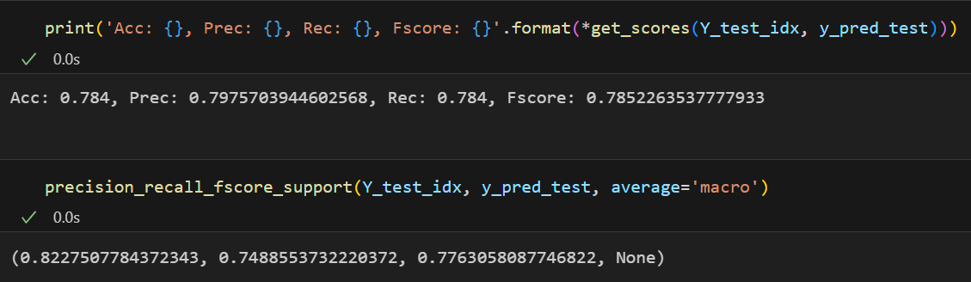

**Report results of feature ablation study and state which feature has contributed most towards correctly predicting a particular class**

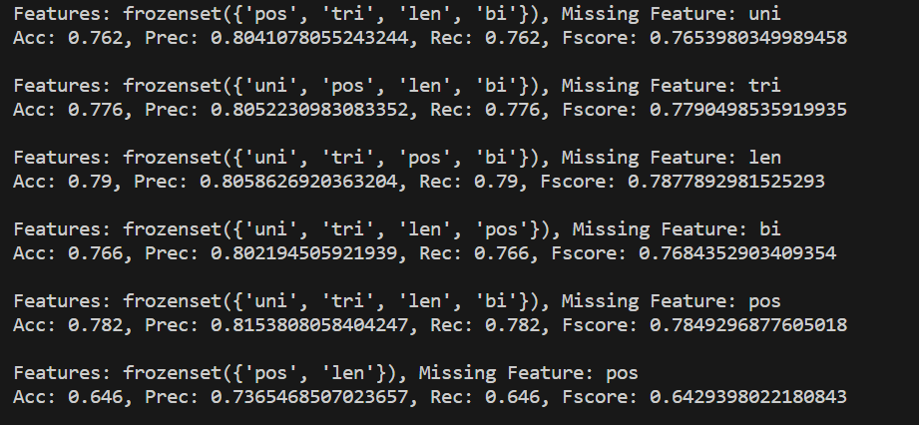

We have printed out accuracy values for each of the class predictions using all possible feature combinations which will help to determine the dependency of a particular feature in predicting a particular class.

**Report precision, recall, and F-score measures on test sets using models based on the gini index, mis-classification error and cross-entropy.**

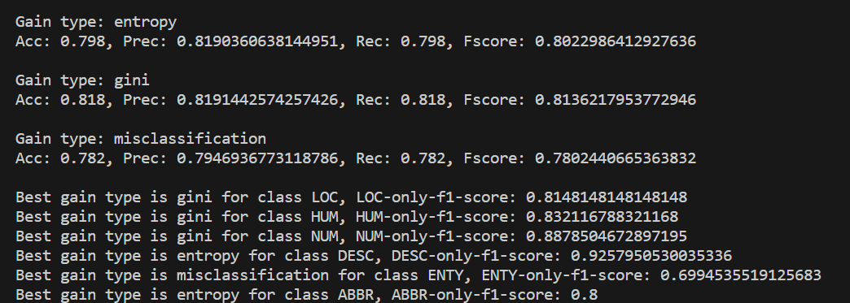

**Show whether errors propagated by one model are corrected by other models or not. If yes, then report how many percent of samples are**

**Corrected.**

**Ex. Observe how many samples are mis-classified using gini index based model but correctly classified by mis-classification error and cross-entropy based model.**

